**Configure Hive metastore in MySQL Server**

Hive by default comes with Derby as its metastore storage, which is suited only for testing purposes and in most of the production scenarios it is recommended to use MySQL as a metastore. This is a step by step guide on How to Configure MySQL Metastore for Hive in place of Derby Metastore (Default).

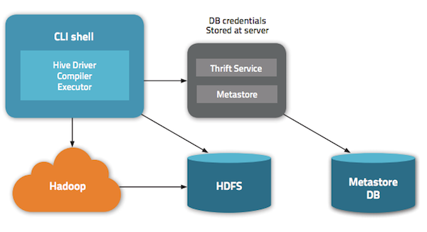

**Install and configure MySQL as linux service**

1. Download and install MySQL Server

[root@localhost Desktop]# yum install mysql-server

1. Install mysql-java-connector (JDBC Driver)

[root@localhost Desktop]# yum install mysql-connector-java

** the jar will be downloaded in /usr/share/java directory. Create a Symbolic link for the jar as :

ln -s /usr/share/java/mysql-connector-java.jar $HIVE_HOME/lib/mysql-connector-java.jar

1. # /sbin/chkconfig mysqld on
2. #/sbin/chkconfig --list mysqld

mysqld 0:off 1:off 2:on 3:on 4:on 5:on 6:off

1. # service mysqld start

Starting mysqld: [ OK ]

**Setting up MySQL User Access**

1. /usr/bin/mysql_secure_installation
2. Enter current password for root (enter for none):<Please enter root>
3. OK, successfully used password, moving on...
4. [...]
5. Set root password? [Y/n] n
6. Remove anonymous users? [Y/n] Y
7. [...]
8. Disallow root login remotely? [Y/n] N
9. [...]
10. Remove test database and access to it [Y/n] Y
11. [...]
12. Reload privilege tables now? [Y/n] Y
13. All done!

**Create Hive metastore**

$ mysql -u root -p

Enter password:

mysql> CREATE DATABASE metastore;

mysql> USE metastore;

**Load schema for hive metastore**

mysql> SOURCE /usr/lib/hive/scripts/metastore/upgrade/mysql/hive-schema-0.10.0.mysql.sql;

**Create hive user and provide privileges**

mysql> CREATE USER 'hive'@'%' IDENTIFIED BY ‘welcome1’;

mysql> CREATE USER 'hive’@‘namenode_machine_hostname_for_your_cluster' IDENTIFIED BY 'mypassword’;

mysql> REVOKE ALL PRIVILEGES, GRANT OPTION FROM 'hive'@'%';

mysql> GRANT SELECT,INSERT,UPDATE,DELETE,LOCK TABLES,EXECUTE ON metastore.* TO 'hive'@'%';

mysql> FLUSH PRIVILEGES;

mysql> quit;

**vi $HIVE_HOME/conf/hive-site.xml  and edit the file for the given properties**

<property>

  <name>javax.jdo.option.ConnectionURL</name>

  <value>jdbc:mysql://myhost/metastore</value>

  <description>the URL of the MySQL database</description>

</property>

<property>

  <name>javax.jdo.option.ConnectionDriverName</name>

  <value>com.mysql.jdbc.Driver</value>

</property>

<property>

  <name>javax.jdo.option.ConnectionUserName</name>

  <value>hive</value>

</property>

<property>

  <name>javax.jdo.option.ConnectionPassword</name>

  <value>mypassword</value>

</property>

<property>

  <name>datanucleus.autoCreateSchema</name>

  <value>false</value>

</property>

<property>

  <name>datanucleus.fixedDatastore</name>

  <value>true</value>

</property>

<property>

  <name>datanucleus.autoStartMechanism</name>

  <value>SchemaTable</value>

</property>

**Start the metastore server**

$>hive --service metastore

(This is a continuously running service, if u don’t get any error for 30 seconds, all is well, but you will not return to $ prompt as it is a continuously running service)

1. **Test the setup**

$> hive

**hive> create table demo (name string);**

Open another terminal window and start mysql client as given below and test the existence of the metadata of the table you created above.

1. $mysql -u hive -p
2. mysql> use metastore;
3. mysql> select * from TBLS;
4. We should get the following output

mysql> select * from TBLS;

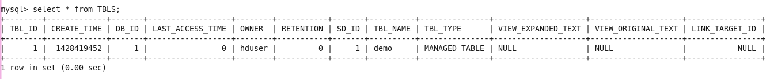

Now hive uses the metastore you configured.